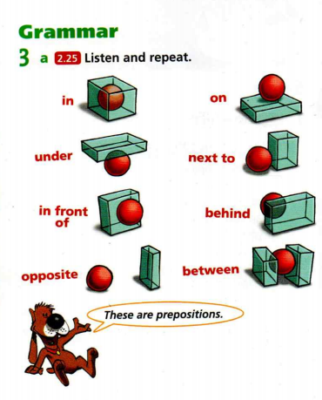
5. třída - PREPOSITIONS OF PLACE (Předložky místa)
in = v on = na
under = pod next to = vedle
in front of = před behind = za
opposite = naproti between = mezi

